**Soil Erosion Mapping of Bagmati Province Nepal using RUSLE Method**

**Annan Shrestha**

1. **Introduction**

Soil erosion presents a significant global challenge, with estimates indicating that the average rate of soil loss worldwide ranges between 12 - 15 ta/ha/yr [1], meaning that every year the land surface losses are about 0.90 - 0.95 mm of soil [2]. In contemporary times, the synergistic effects of climate change and anthropogenic environmental impacts have elevated erosion to a critical environmental concern in numerous regions worldwide [3-4]. Soil erosion is one of the major factors causing destruction and sustainability of agriculture in the upland is soil erosion [5]. Soil erosion by rainfall and surface water flow is generally affected by five factors: Rainfall erosivity, soil erodibility, topography, surface coverage, and support practices [6].

Several models exist to predict the extent of water induced erosion [7]. This study uses the RUSLE model and arcpy, python and GIS to quantify and understand the spatial distribution of soil erosion in Bagmati Province of Nepal.

1. **Objectives**

The primary objective of this project is to develop a soil erosion risk map for Bagmati Province utilizing the Revised Universal Soil Loss Equation (RUSLE) model in conjunction with geospatial technologies. This map will identify regions with elevated erosion risks and highlight districts that are particularly vulnerable to such events.

1. **Materials and Study Area**
   1. **Study Area**

Bagmati Province, located in central Nepal, spans an area of approximately 20,300 square kilometers, making it the fifth largest province in the country. The province shares a northern border with the Tibet Autonomous Region of China and is known for its diverse topography, ranging from the lush, lowland forests of the Terai to the high-altitude mountainous areas in the north. Bagmati Province experiences a humid subtropical climate in the lower areas, while the mountainous regions to the north have an alpine climate, with cooler temperatures and heavier snowfalls. The province’s varied terrain includes the Mahabharat Range and sections of the Himalayan foothills, shaping its distinct ecosystems and supporting rich biodiversity. Economic activities include agriculture, tourism, and service industries, reflecting Bagmati's strategic importance in Nepal.

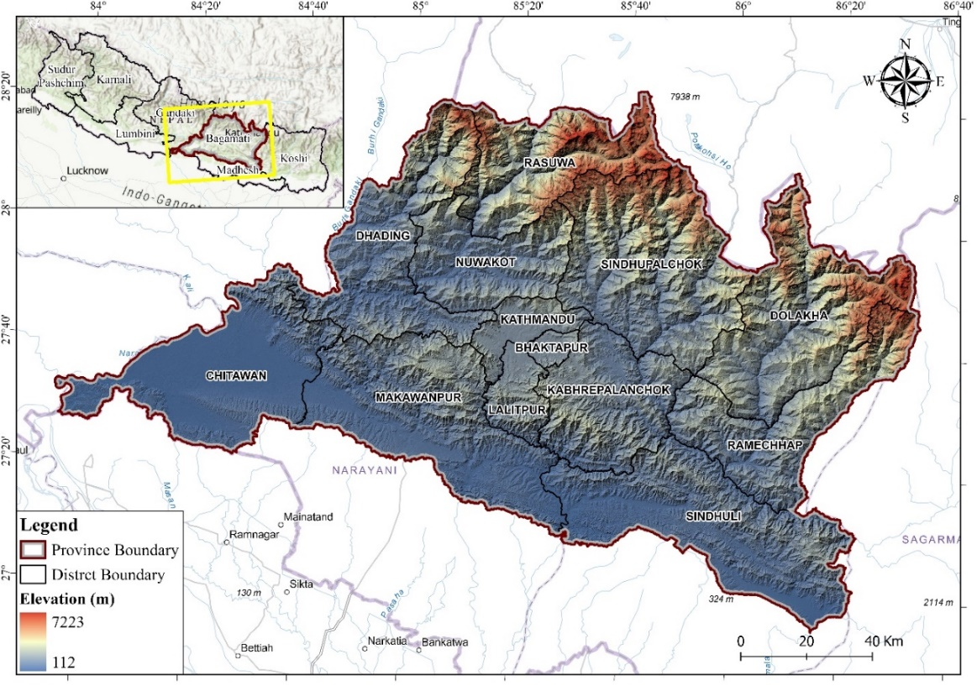

**Figure 1: Study Area Map Showing Bagmati Province**

* 1. **Data Collection**

The study used various spatial datasets acquired from different sources. The dataset and their respective sources are shown in Table 1.

**Table 1: Datasets Used in RUSLE Model**

|  |  |
| --- | --- |
| **Datasets** | **Data Sources** |
| DEM | SRTM DEM (30 m)  <https://earthexplorer.usgs.gov/> |
| Soil Data | Digital Soil Map of Nepal  <https://soil.narc.gov.np/getdata> |
| Landcover Map | ESRI Landcover Data 2023  [Esri | Sentinel-2 Land Cover Explorer](https://livingatlas.arcgis.com/landcoverexplorer/#mapCenter=-83.21000%2C34.33200%2C4&mode=step&timeExtent=2017%2C2021&year=2017&downloadMode=true) |
| Rainfall Data | Mean Annual Precipitation from DHM |

* 1. **Methods**

The RUSLE model was used in the arcpy environment in this study to prepare soil erosion maps. The RUSLE is expressed by the equation

A = [R]*[K] *[LS]*[C]*[P],

where, A = soil loss (t ha-1yr-1), R = rainfall erosivity factor (MJ mm ha-1h-1yr), K = soil erodibility factor (t h MJ-1 mm-1), LS = slope-length and slope steepness factor (dimensionless), C=land management factor (dimensionless), and P = conservation practice factor (dimensionless).

**Figure 2: The methodological framework of implementing the RUSLE model for soil erosion estimation**.

* + 1. **RUSLE Parameters Computation**

1. **Rainfall Erosivity (R)**

The rainfall erosivity factor (R) quantifies the erosive potential of rainfall at a specific location, considering both the amount and intensity of precipitation [8]. In this study, a rainfall map was developed using monthly data from 29 rainfall stations within the Bagmati Province, spanning the years 2012 to 2024. This data was instrumental in calculating the rainfall erosivity factor. The equation employed to generate the R-factor is detailed in the reference [9].

R= 38.5+0.35P

where, R = Rainfall Erosivity Factor, P = Mean Annual Rainfall in mm

1. **Soil Erodibility Factor (K)**

The soil erodibility factor K quantifies the inherent erodibility of a soil representing its vulnerability to erosion by water. The main soil properties influencing the K factor are soil texture, organic matter, soil structure and permeability of the soil profile. The equations employed to generate the K factor is provided by the reference [10].

K = Fcsand*Fsi-cl*Forgc*Fhisand*0.1317

Where,

*Fcsand = [0.2+0.3exp(-0.0256*SAN(1-))]*

*Fsi-cl = [*

*Forgc = [1-*

*Fhisand = =[1-*

where, SAN, SIL and CLA are % sand, silt, and clay, respectively; C is the organic carbon content; and SN1 is sand content subtracted from 1 and divided by 100.

Fcsand = it gives a low soil erodibility factor for soil with coarse sand and a high value for soil with little sand content.

Fsi-cl = it gives a low soil erodibility factor with high clay to silt ration.

Forgc = it is the factor that reduces soil erodibility for soil with high organic content.

Fhisand= it is the factor that reduces soil erodibility for soil with extremely high sand content.

1. **Topographic Factor (LS)**

The topographic factor, commonly referred to as the Slope Length and Steepness Factors (LS), is derived from two key components: the slope gradient factor (S) and the slope-length factor (L). These components are calculated using data from the Digital Elevation Model (DEM). In soil erosion modeling, the slope length and gradient are critical parameter [11], particularly in determining the transport capacity of overland flow, also known as surface runoff.

The slopes' gradient and slope length factors were derived from the Digital Elevation Model (DEM) and integrated to produce the topographical factor grid, utilizing the following equation [12].

L =

Where, m = slope-length exponent, flowacc = flow accumulation

For slope gradient factor,

S =Con ((Tan (slope 0.01745) < 0.09), (10.8 Sin (slope 0.01745) + 0.03), (16.8 Sin (slope 0.01745) 0.5)),

Final, LS = L*S

1. **Cover Management (C)**

In this study, Land Use/Land Cover (LULC) data provided by the Environmental Systems Research Institute (ESRI) was employed to develop a C-factor map. First, the raster map was converted to polygon and the attributes with same land use type were merged in ArcPro. From these six types of land use were obtained. For each land use type, C values were assigned through reference [13].

The C factor, which varies from 0 to roughly 1, serves as an indicator of the impact of vegetative cover on soil erosion. Higher values of the C factor signify minimal protective effects from the cover, leading to soil loss akin to that observed in tilled, bare fallow conditions. Conversely, lower C factor values denote a robust protective influence from the cover, effectively mitigating erosion to negligible levels [14].

**Table 2: Cover Management Factor**

|  |  |
| --- | --- |
| Landuse | C Factor |
| Water | 0.00 |
| Built-Up | 0.00 |
| Grassland | 0.01 |
| Forest | 0.03 |
| Agriculture Land | 0.21 |
| Barren Land | 0.45 |

1. **Support Practice Factor (P)**

The support practice factor quantifies the rate of soil erosion across different types of agricultural lands. This factor encompasses various management techniques such as contour farming, crop rotation, and terracing. It plays a crucial role in mitigating soil erosion, making it an essential consideration in sustainable land management practices [15]. P values span from 0 to 1, with 0 signifying excellent resistance to anthropic erosion and 1 indicating minimal resistance (Table 3). In Nepal, agricultural practices on sloping lands often involve the construction of terraces, which mimic contour farming, a method aimed at soil conservation. Thus, we consider the contour farmland as an agricultural support practice

**Table 3: P factor values for slope as per agricultural practice** [15]

|  |  |
| --- | --- |
| Slope% | Contouring |
| 0-7 | 0.55 |
| 7-11.3 | 0.60 |
| 11.3-17.6 | 0.80 |
| 17.6-26.8 | 0.95 |
| >26.8 | 1.00 |

1. **Results**
   1. **Factor Maps**

The analysis revealed that the Rainfall Erosivity Factor (R) spanned from 62.59 to 151.14 MJ mm ha⁻¹ h⁻¹ yr⁻¹. The Soil Erodibility Factor (K) varied between 0.018 and 0.04. Across the entire region, the Topographic Factor (LS) ranged from 0.031 to 45.215. The Cover Management Factor (C) values were found to lie between 0 and 0.45. Additionally, the Support Practice Factor (P) ranged from 0.55 to 1.

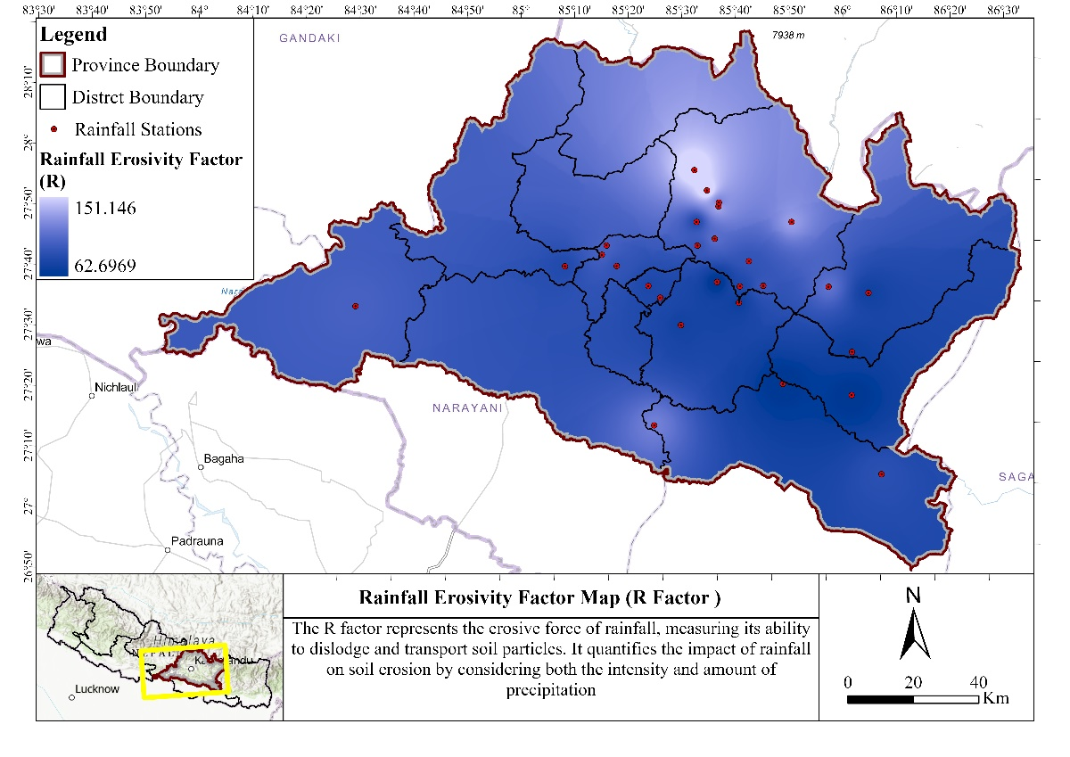

**Figure 3: Rainfall Erosivity Factor (K)**

**Figure 4: Soil Erodibility Factor (K)**

**Figure 5: Topographic Factor (LS)**

**Figure 6: Cover Management Factor (C)**

**Figure 7: Support Practice Factor (P)**

* 1. **Potential Soil Erosion Rate**

The potential erosion map of Bagmati Province has been produced using Arcpy and Arc Pro. It has been found that the erosion ranges from 0.02 to 807 t h⁻¹ yr⁻¹ for the entire area. The total annual mean soil loss has been estimated to be 47.903 t h⁻¹ yr⁻¹. Observing the map, it can be seen that areas which are at higher elevation are more susceptible to rates of erosion.

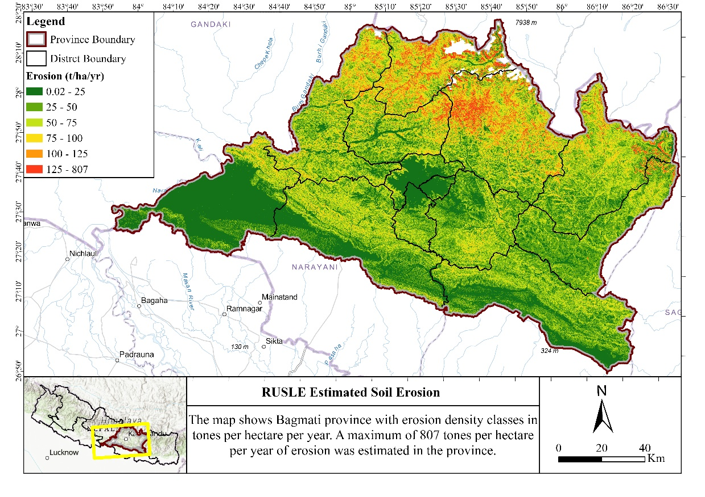

**Figure 8: Potential Erosion Rate Map**

**Table 4: Erosion rate showing Classes of Erosion**

|  |  |  |
| --- | --- | --- |
| Tons/ha/yr | Area (Hectares) | Percent |
| 0.02- 25 | 554709.8 | 27.88256 |
| 25-50 | 559540.4 | 28.12537 |
| 50-75 | 503540.8 | 25.31054 |
| 75-100 | 239948.1 | 12.06102 |
| 100-125 | 78923.07 | 3.967078 |
| 125-807 | 52788.69 | 2.65343 |

* + 1. **Erosion by District**

**Figure 9: Average Erosion Rate and Total Erosion by District**

This figure provides a comprehensive view of soil erosion rates and total erosion across various districts, highlighting areas with higher erosion risks that may require targeted conservation efforts.

Bhaktapur demonstrates the lowest average erosion rate at 11.53 tons/ha/yr, coupled with the lowest cumulative erosion rate of 242,476.54 tons/ha/yr, indicating relatively minor erosion issues in this district. Conversely, Rasuwa exhibits the highest average erosion rate at 85.35 tons/ha/yr, with a cumulative erosion rate of 2,731,897.92 tons/ha/yr. The specifics for each district are illustrated in the figure.

The data highlights the need for district-specific approaches to address erosion challenges, with a particular focus on regions like Sindhupalchok, Rasuwa, and Dhading, where erosion rates are alarmingly high.

1. **Conclusions**

Soil erosion is a global issue with its major impact being on agricultural lands. The importance of the study is to produce the spatial distribution of soil erosion of Bagmati Province, which can be used the conservation and management planning processes, The output is based on the model RUSLE processed in ArcPy, ArcGIS Pro and Python. The five factors that influence soil erosion by water include rainfall erosivity, soil erodibility, topography, cover, and support practices. The annual mean soil loss has been estimated to be 47.903 t h⁻¹ yr⁻¹. It has been found that the erosion rate of Bagmati Province varies from as low as 0.02 t to 807 t h⁻¹ yr⁻¹. By Physiographic region it has been found that the region in lower elevation has the lowest erosion potential compared to the regions in higher elevation.

**References**

1. Biggelaar, C.; Lal, R.; Eswaran, H.; Breneman, V.E.; Reich, P.F. Crop Losses to Soil Erosion at Regional and Global Scales: Evidence from Plot-Level and GIS Data. In Land Quality, Agricultural Productivity, and Food Security; Wiebe, K., Ed.; Edward Elgar: Cheltenham, UK, 2003; pp. 262–279.
2. FAO; ITPS. Status of the World’s Soil Resources (SWSR)–Main Report; Food and Agriculture Organization of the United Nations and Intergovernmental Technical Panel on Soils: Rome, Italy, 2015.
3. Julien PY. Erosion and sedimentation. Cambridge University Press, Cambridge, 1998
4. Rozos D, Skilodimou HD, Loupasakis C, Bathrellos GD. Application of the revised universal soil loss equation model on landslide prevention. An example from N. Euboea (Evia) Island, Greece. Environ Earth Sci DOI [10.1007/s12665-013-2390-3](https://doi.org/10.1007/s12665-013-2390-3), 2013.
5. Blaikie, P.; Brookfield, H. Land Degradation and Society; Routledge: London, UK, 1987.
6. Renard, K.G.; Foster, G.; Weesies, G.; McCool, D.; Yoder, D. Predicting Soil Erosion by Water: A Guide to Conservation Planning with the Revised Universal Soil Loss Equation (Rusle); United States Department of Agriculture: Washington, DC, USA, 1997; Volume 703.
7. Brady, C.N.; Weil, R.R. The Nature and Properties of Soils, 14th ed.; Prentice Hall: Upper Saddle River, NJ, USA, 2008.
8. Koirala, Pooja, Sudeep Thakuri, Subesh Joshi, and Raju Chauhan. "Estimation of soil erosion in Nepal using a RUSLE modeling and geospatial tool." *Geosciences* 9, no. 4, 2019: 147.
9. Morgan, R.P.C. Soil Erosion and Conservation; Soil Conservation Society of America: Ankeny, lowa, 1985.
10. Sharpley, A.N.; Williams, J.R. Erosion/Productivity Impact Calculator: 1. Model Documentation. USA Dep. Agric. Tech. Bull. 1990, 1768, 235.
11. Morgan, R.P.C.; Morgan, D.D.V.; Finney, H.J. A predictive model for the assessment of soil erosion risk. J. Agric. Eng. Res. 1984, 30, 245–253.
12. Gao, G.Y.; Fu, B.J.; Liu, Y.; Wang, S.; Zhou, J. Coupling the modified SCS-CN and RUSLE models to simulate hydrological effects of restoring vegetation in the Loess Plateau of China. Hydrol. Earth Syst. Sci. 2012, 16, 2347–2364.
13. Panagos, P.; Borrelli, P.; Meusburger, K.; Alewell, C.; Lugato, E.; Montanarella, L. Land Use Policy Estimating the soil erosion cover-management factor at the European scale. Land Use Policy 2015, 48, 38–50.
14. Erencin, Z. C-Factor Mapping Using Remote Sensing and GIS; A case Study of Lom Sak/Lom Kao, Thailand; International Institute for Aerospace Survey and Earth Sciences (ITC): Upper Aise, The Netherlands, 2000.
15. Shin, G.J. The Analysis of Soil Erosion Analysis in Watershed Using GIS. Ph.D. Thesis, Kangwon National University, Chuncheon, South Korea, 1999.